a) Sample output from running the program as is:

1 factor MC with explicit Euler

Number of subintervals in time: 100

Number of simulations: 50000

10000

20000

30000

40000

50000

Price, after discounting: 5.87749,

Number of times origin is hit: 0

b) I modified the code (TestGroup_D.cpp) so that it cycles through a set of NT values (between 100 and 1000) and a set of NSIM values (between 10,000 and 10,000,000) for each option. I then calculated and charted the deviation between estimated prices and exact price from Black Scholes. Deviation is calculated as $\frac{estimated price}{exact price}-1$.

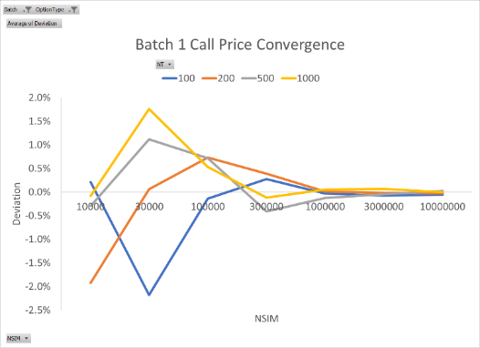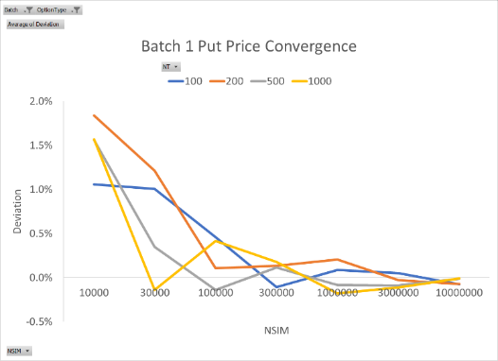

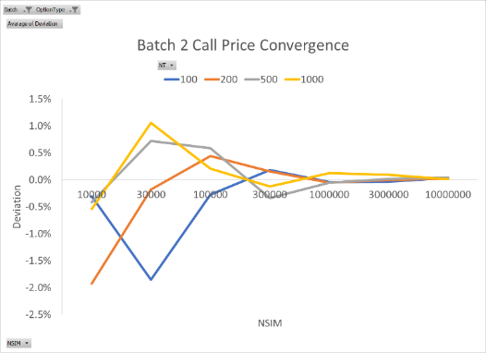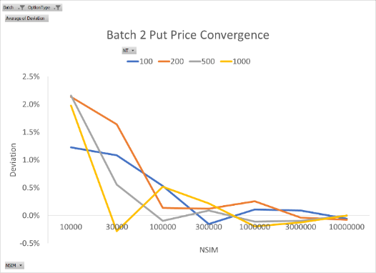

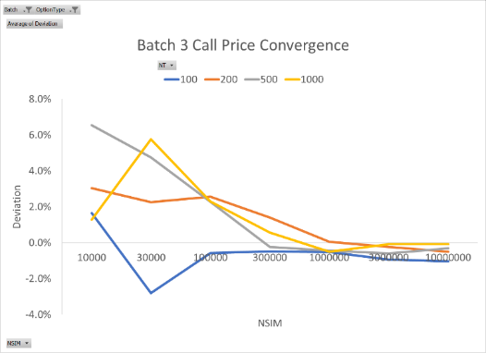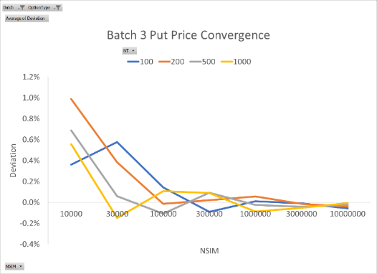

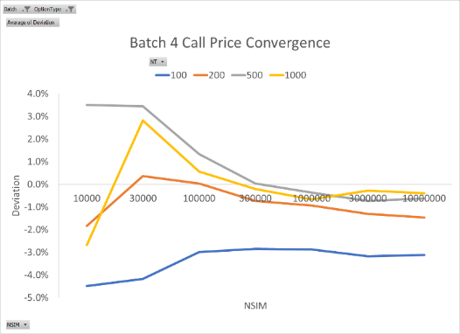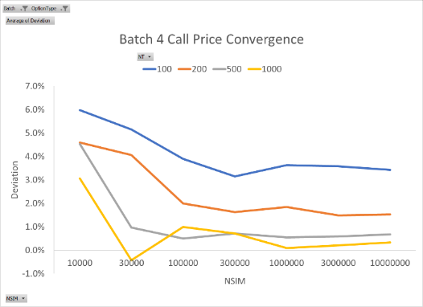

The estimated price converges to the exact price at high NSIM. High NT values also seem to help with convergence, especially for an option with longer horizon, such as Batch 4. Note that call prices and put prices each have a similar pattern of convergence across all four batches. This may be due to either a lack of true randomness of the underlying RNG or an artifact of using explicit Euler-Maruyama scheme for solving SDEs.

The estimated prices never got to the same accuracy as the exact solution for Batch 1 and 2. However, for the following combinations of (NT, NSIM), the estimated prices got within 0.001 of the exact prices.

|  |  |  |  |  |  |  |
| --- | --- | --- | --- | --- | --- | --- |
| Batch 1 Call |  | Batch 1 Put |  | Batch 2 Call |  | Batch 2 Put |
| (100, 1 mil)  (200, 1 mil)  (200, 3 mil)  (200, 10 mil)  (500, 10 mil)  (1000, 10 mil) |  | (500, 10 mil)  (1000, 10 mil) |  | (200, 3 mil)  (1000, 10 mil) |  | (500, 10 mil)  (1000, 10 mil) |

c) For the following combinations of (NT, NSIM), the estimated prices got within 0.01 of the exact prices.

|  |  |  |
| --- | --- | --- |
| Batch 4 Call |  | Batch 4 Put |
| None |  | (500, 100 k)  (500, 300 k)  (500, 1 mil)  (500, 3 mil)  (500, 10 mil)  (1000, 30 k)  (1000, 300 k)  (1000, 1 mil)  (1000, 3 mil)  (1000, 10 mil) |

As before, both higher NT and NSIM help increase accuracy of the estimated prices. The effect of high NT is especially pronounced in this case due to long horizon.